IPB for AO Moonraker
LOCATION, STATE
YYYYMMDD
ANALYST/TEAM

AREA OF OPERATIONS / AREA OF INTEREST 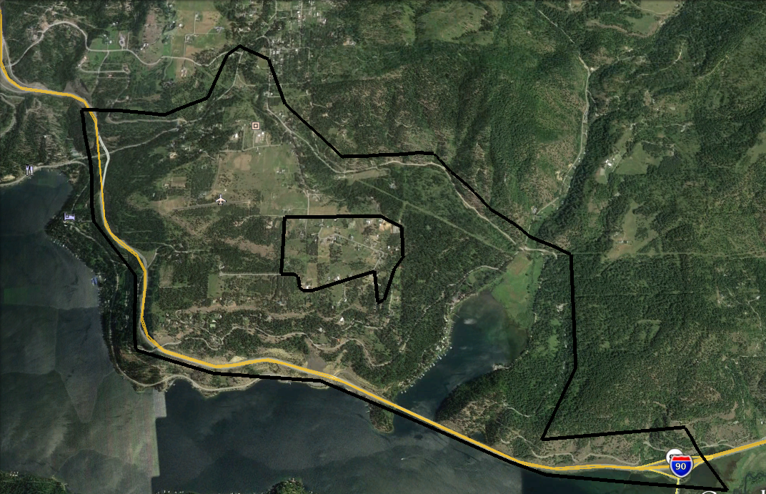

(DESCRIPTION HERE: The Area of Operations (AO) is x miles southeast of x town in x county. The Area of Interest (AI) includes x terrain features, x critical infrastructure, and x primary routes.

ROUTE MAP OF AI

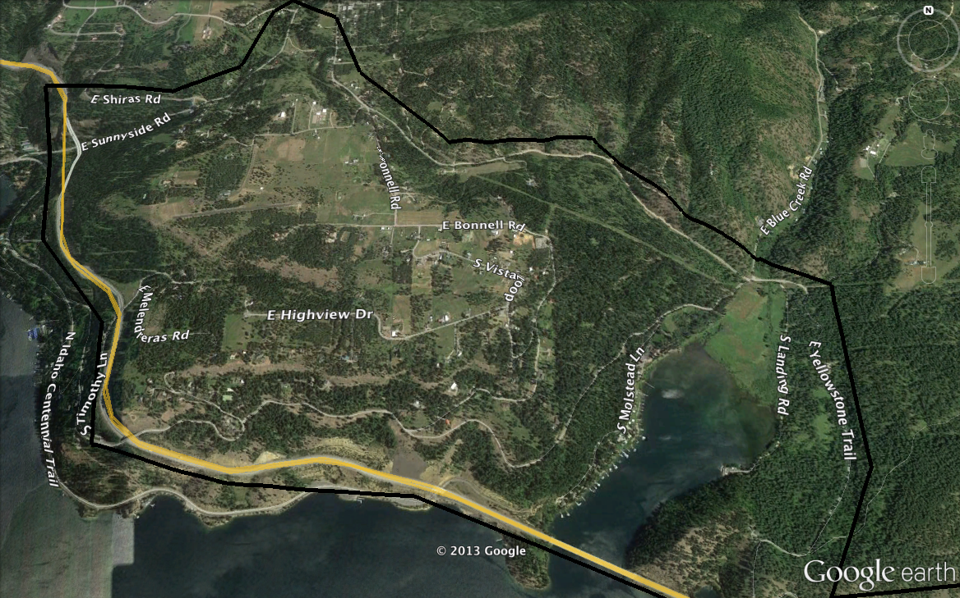

Include road maps and any other layers you build.

PRIMARY ROUTES WITHIN THE AI
Interstate 90

SECONDAR Y ROUTES WITHIN THE AI
East Shiraz Road
East Sunnyside Road
Bonnell Road
East Melenderas Road
South Molstead Lane
South Landing Road
East Yellowstone Trail
South Timothy Lane

ROUTE MAP OF AO
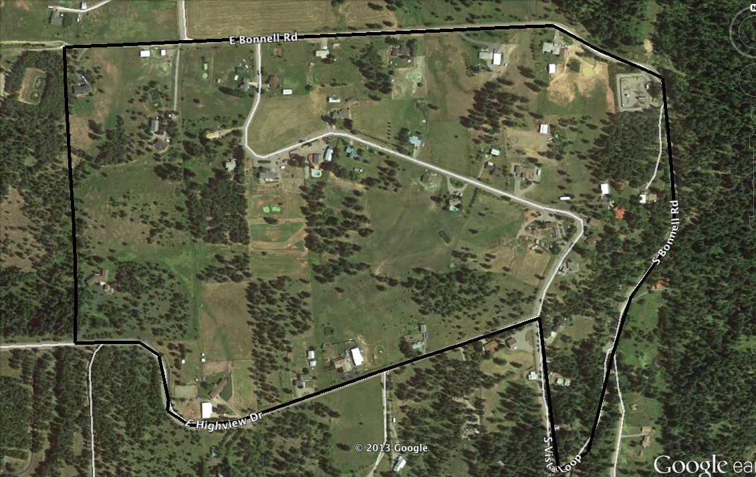

Include road maps and any other layers you build.

PRIMARY ROUTES WITHIN THE AO
N/A

SECONDARY ROUTES WITHIN THE AO
East Bonnell Road
South Bonnell Road
South Vista Loop
East Highview Drive

GEOGRAPHIC TERRAIN INTELLIGENCE REQUIREMENTS
1. What is the physical terrain that affects my area? (ANSWER IRs BELOW; INCLUDE SOURCE INFORMATION.)
2. How does the physical terrain affect my area?
3. What physical terrain is the most likely to change?
4. What man-made obstacles will affect my area?
5. What seasonal climate factors affect my area?
6. What electrical infrastructure affects my area?
7. What hydrological features affect my area?
9. What are the primary transportation routes in my area?
10. What are the secondary transportation routes in my area?

HUMAN TERRAIN INTELLIGENCE REQUIREMENTS
1. What is the population density in my area?
2. Identify the areas of homogenous race, ethnicity, culture, and religion.
3. What is the socioeconomic breakdown in my area?
4. What are the crime patterns and high-crime sections in my area?
5. Identify the civic and social organizations in the area.
6. What media outlets affect my area?
7. Which groups or sub-groups are most aligned with our goals?
8. Which groups or sub-groups are least aligned with our goals?
9. Which groups or sub-groups will likely have a disposition towards violence during an emergency?
10. Which groups or sub-groups have the most in common with other groups or sub-groups?
11. Who are the leaders or individuals who hold influence over each group or sub-group?

POLITICAL TERRAIN INTELLIENCE REQUIREMENTS
1. Who is the political leadership in my county/AO?
2. Who are the civil servants who wield political influence?
3. Who are the civil servants who wield administrative influence?
4. Who are the known pro-Constitution politicians and civil servants?
5. Who are the known statist/anti-Constitution politicians and civil servants?
6. What is the organizational structure of county governance?
7. What are the perceived strengths of the county government?
8. What are the perceived weaknesses of the county government?
9. How effective at maintaining security will the county government during an emergency?
10. What is the overall quality of governance of the county government?
11. Where are the county and local government offices and buildings?

ECONOMIC INTELLIGENCE REQUIREMENTS
1. Who are the major job providers in the county?
2. What industries operate in the county?
3. What are the service industries dependent on industrial production?
4. What is the unemployment in the county?
5.What are the trends or indicators regarding economic stability?
6. What factors threaten future economic stability?
7. What is the distribution of socioeconomic levels?
8. What are the dual-use manufacturing companies?
9. Where are the manufacturing plants?
10. Which economic infrastructures are directly related to the political infrastructure?

SECURITY INTELLIGENCE REQUIREMENTS
1. Identify the state and local law enforcement organizations in the AO.
2. Identify the federal law enforcement organizations in the AO.
3. Identify the organizational structure of law enforcement organizations in the AO.
4. Identify the leadership of law enforcement organizations in the AO.
5. What is the strength and disposition of law enforcement organizations in the AO?
6. What are the attitudes of law enforcement leadership towards the Constitution/Liberty in the AO?
7. Which law enforcement officers are pro-Statist/anti-Bill of Rights?
8. Identify the private security apparatus in the AO.
9. What is the quality of security in the AO?
10. What is the quality of justice in the AO?
11. How does the populace view law enforcement in the AO?

DEFENSE INTELLIGENCE REQUIREMENTS
1. What military installations are in the AO?
2. What is the strength and disposition of active duty forces in the AO?
3. What is the strength and disposition of Reserve/National Guard forces in the AO?
4. What are the capabilities of all federal and state military forces in the AO?
4. Which units are trained to provide security and/or force projection in the AO?
6. Identify the leadership of military units that could provide security in the AO.
7. What are the attitudes of military leaders towards the Constitution?
8. What is the strength and disposition of unorganized militia units in the AO?
9. What are the attitudes of the populace towards military forces in the AO?
10. What are the attitudes of the local government towards military forces in the AO?

MAPS

Terrain
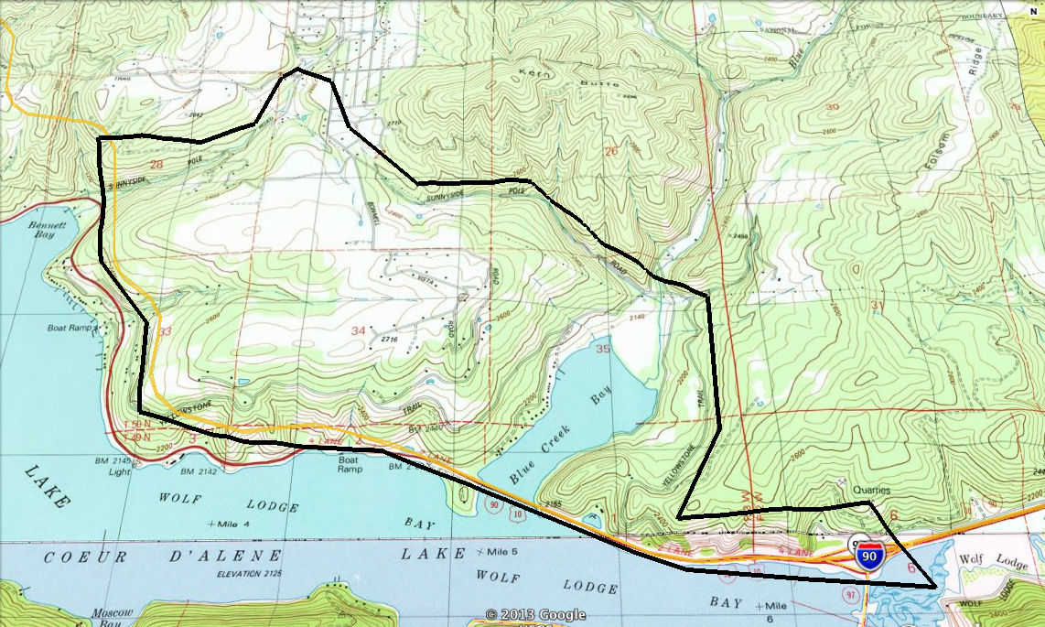
Include your IPB Overlays here.

Median Age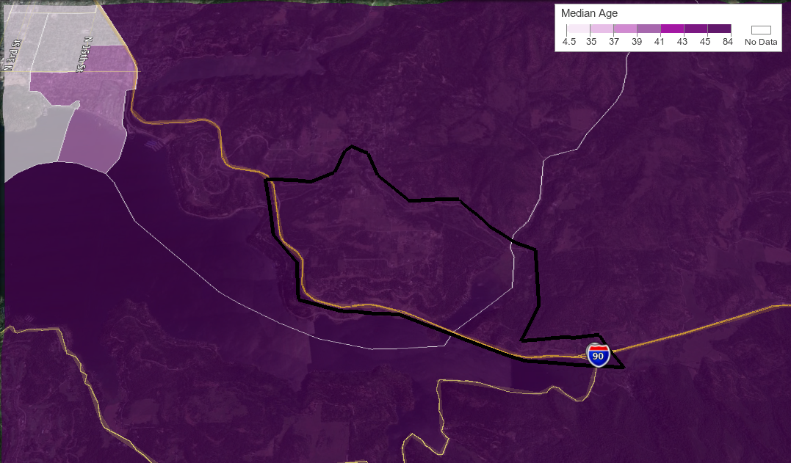
Population Density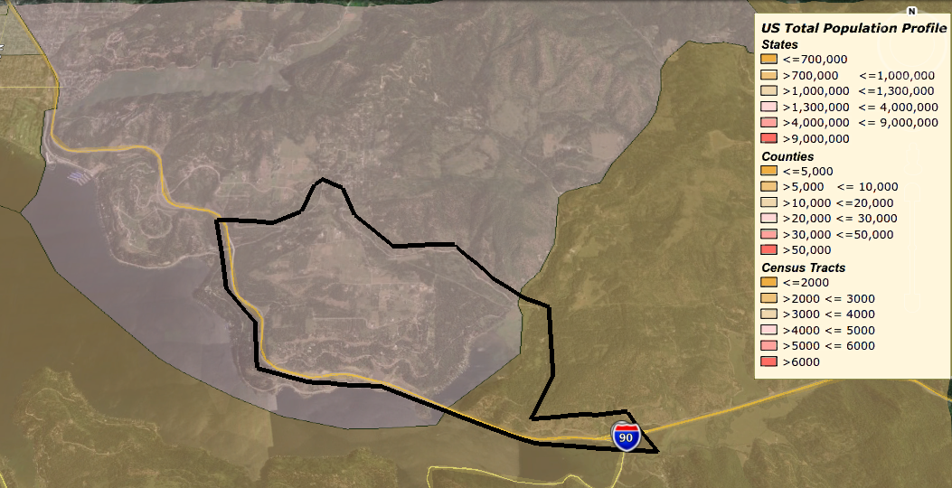

Household Income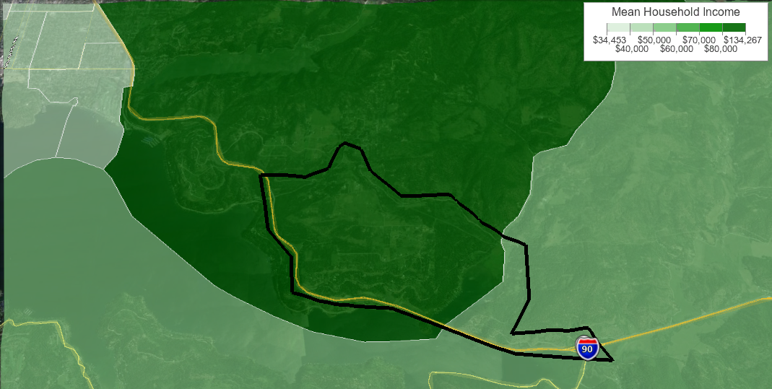

(INCLUDE ANY OTHER MAPS THAT ARE RELEVANT TO YOUR AO/AI.)

METT-TC ANALYSIS
MISSION.
The Neighborhood Security Team will secure, protect and defend the community from conventional and irregular threats.
ENEMY.
Based on our current intelligence holdings, we expect the primary threat to be irregular. Those irregular threats will likely include common individual criminals, and the possibility of gangs and/or roving looters. Early warning of irregular threat activity may be possible through news stations (television and radio) and through ham band contact from others within Kootenai County. The possibility of a conventional threat is diminished, however, mobilization of Army reserve/national guard units is possible. A secondary conventional threat could include state law enforcement agencies. Their potential missions could range from providing security during an emergency to targeting 'extremist elements' and military members throughout the region. We would expect those units to be based locally and likely receive support or direction from regime agencies.
TERRAIN & WEATHER.
Our AO's terrain is conducive to defense, however, our position off a major primary route could make defense more vulnerable. The terrain includes hills that separate the valley from outside areas, and will make ingress moderately difficult but not impossible. The only line of sight into the valley is from the surrounding ridges.
Weather from October to March can be unfavorable for enemy mobility, with the exception to air assets. In the absence of equipment to maintain roads, the accumulation of snow and ice will make road travel difficult, and passes within the region potentially impassible.
TROOPS & SUPPORT.
There are indigenous defense forces, namely a local militia, in the area. We have favorable relationships with local residents and will likely receive considerable support throughout our AO.
TIME.
Our ability to be self-sustainable within the AO is favorable and improving. We estimate that we could be supplied for up to 12 months of heavy operations, and 18-24 months of low intensity operations.
CIVIL CONSIDERATIONS.
Local governance is favorable towards the defense of traditional American values and the Constitution. There are, however, numerous local politicians and organization who will likely seek to disrupt pro-FREEFOR activities. Local news media, as a whole, cannot be counted upon to provide pro-Constitution or pro-FREEFOR coverage. There are stations more amenable to spinning positive stories about local defense forces, while others would easily provide pro-regime influence. Based on the threat, our ability to hold critical infrastructure within our AO is favorable. Our ability to hold critical infrastructure within the AI is questionable, unless we develop similar groups throughout the region.

