IPB for AO Moonraker
LOCATION, STATE
YYYYMMDD
ANALYST/TEAM

AREA OF OPERATIONS / AREA OF INTEREST 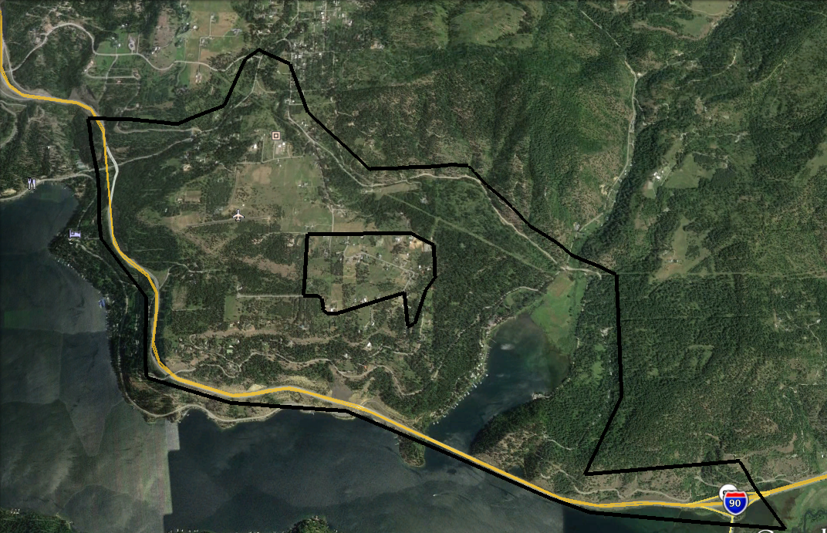

(DESCRIPTION HERE: The Area of Operations (AO) is x miles southeast of x town in x county. The Area of Interest (AI) includes x terrain features, x critical infrastructure, and x primary routes.

ROUTE MAP OF AI

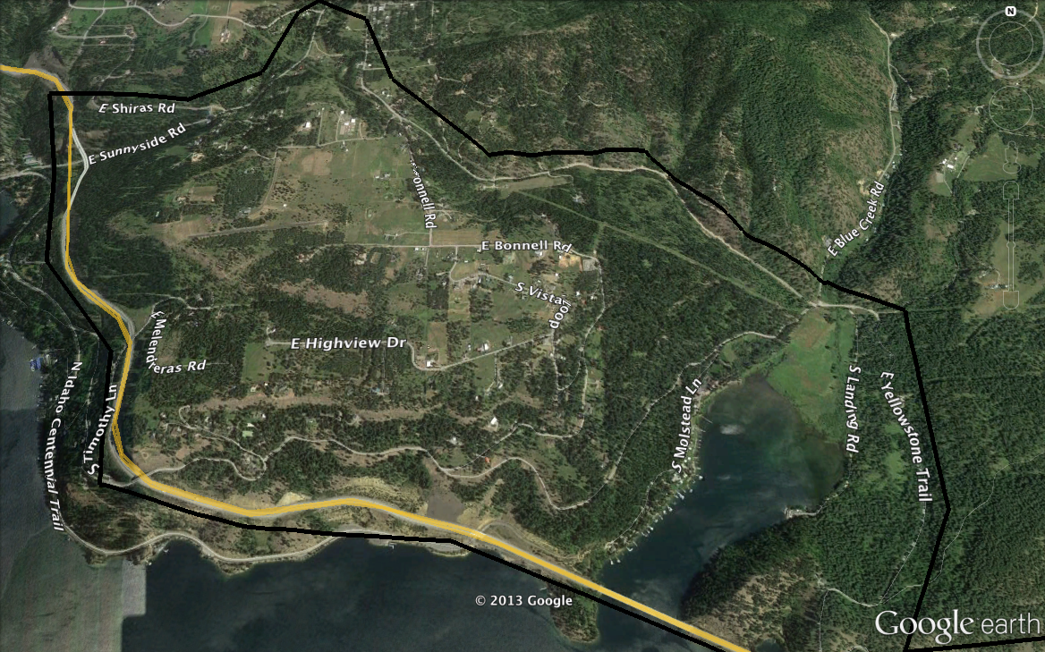

Include road maps and any other layers you build.

PRIMARY ROUTES WITHIN THE AI
Interstate 90

SECONDAR Y ROUTES WITHIN THE AI
East Shiraz Road
East Sunnyside Road
Bonnell Road
East Melenderas Road
South Molstead Lane
South Landing Road
East Yellowstone Trail
South Timothy Lane

ROUTE MAP OF AO
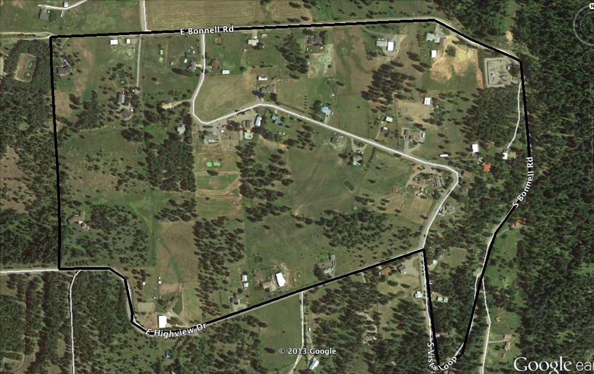

Include road maps and any other layers you build.

PRIMARY ROUTES WITHIN THE AO
N/A

SECONDARY ROUTES WITHIN THE AO
East Bonnell Road
South Bonnell Road
South Vista Loop
East Highview Drive

PHYSICAL TERRAIN INTELLIGENCE REQUIREMENTS

HUMAN TERRAIN INTELLIGENCE REQUIREMENTS

CRITICAL INFRASTRUCTURE INTELLIGENCE REQUIREMENTS

POLITICS/GOVERNANCE INTELLIGENCE REQUIREMENTS

LAW ENFORCEMENT/MIL/SECURITY INTELLIGENCE REQUIREMENTS
ECONOMIC/FINANCIAL INTELLIGENCE REQUIREMENTS

MAPS

Terrain
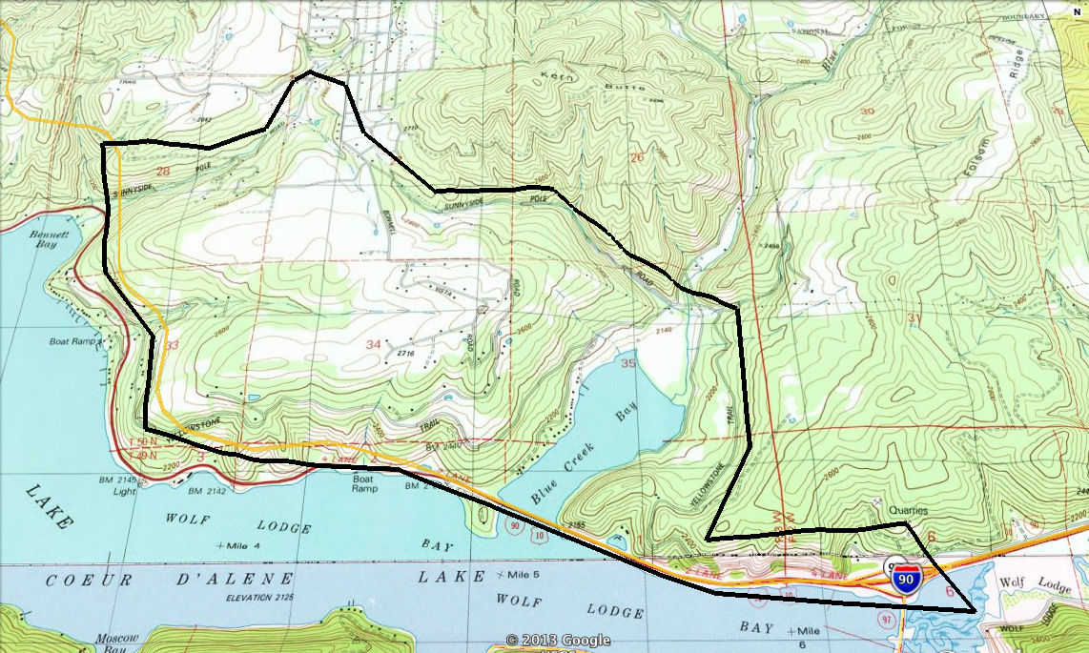
Include your IPB Overlays here.

Median Age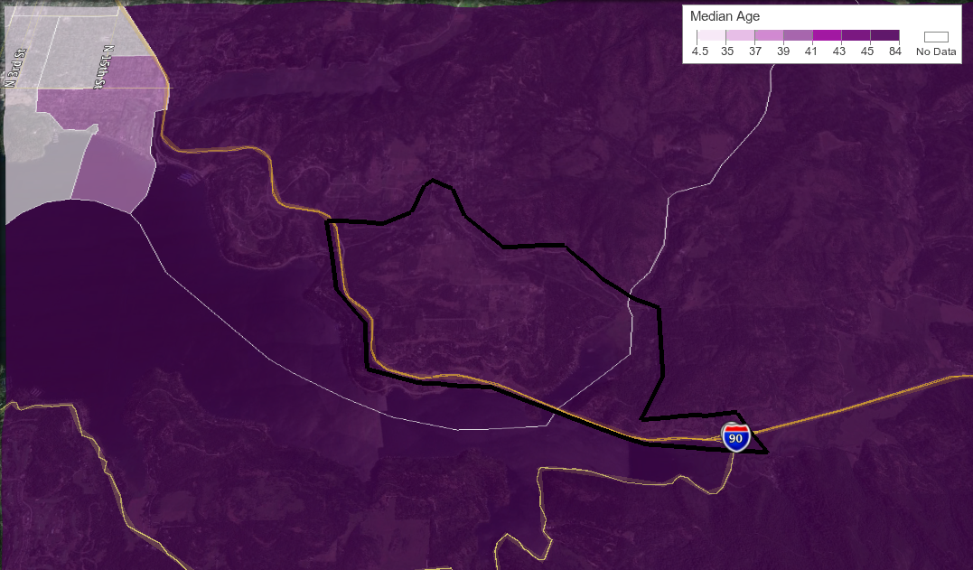
Population Density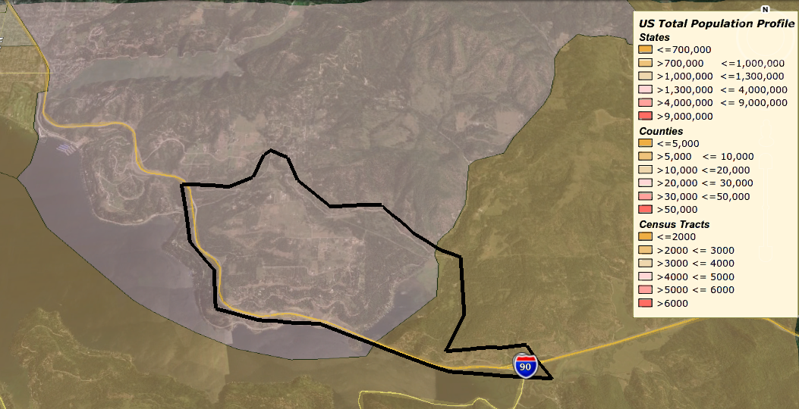

Household Income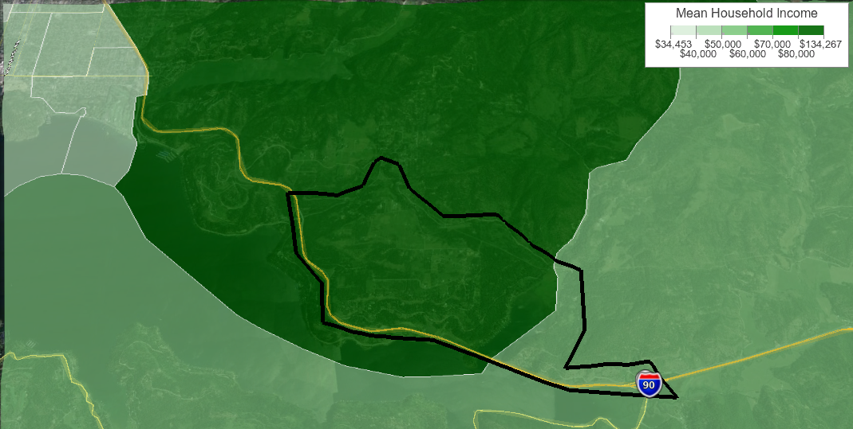

(INCLUDE ANY OTHER MAPS THAT ARE RELEVANT TO YOUR AO/AI.)

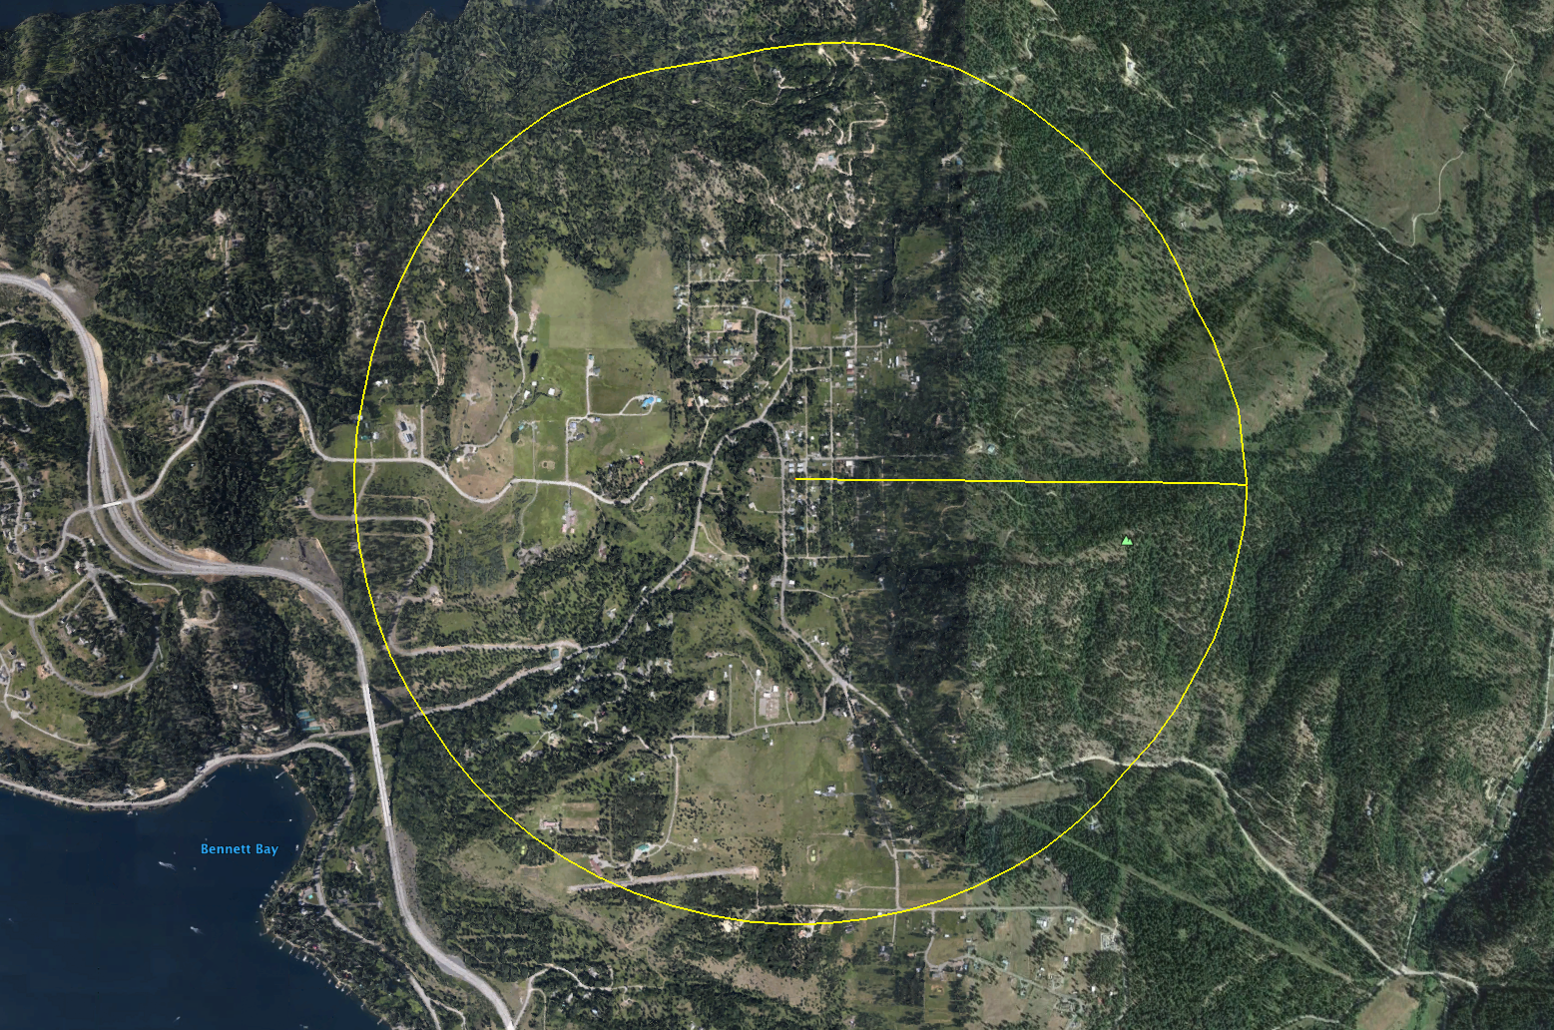

1 Mile Radius

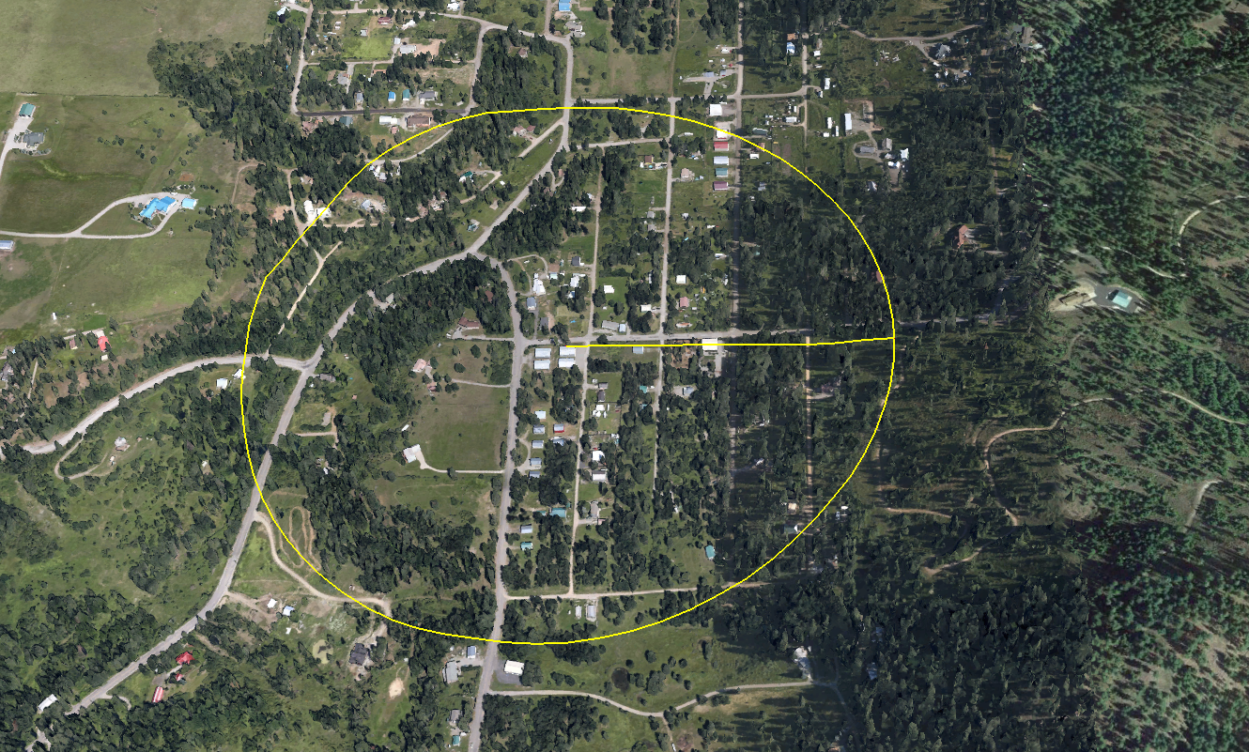
¼ Mile Radius

METT-TC ANALYSIS
MISSION.
The Neighborhood Security Team will secure, protect and defend the community from conventional and irregular threats.
ENEMY.
Based on our current intelligence holdings, we expect the primary threat to be irregular. Those irregular threats will likely include common individual criminals, and the possibility of gangs and/or roving looters. Early warning of irregular threat activity may be possible through news stations (television and radio) and through ham band contact from others within Kootenai County. The possibility of a conventional threat is diminished, however, mobilization of Army reserve/national guard units is possible. A secondary conventional threat could include state law enforcement agencies. Their potential missions could range from providing security during an emergency to targeting 'extremist elements' and military members throughout the region. We would expect those units to be based locally and likely receive support or direction from regime agencies.
TERRAIN & WEATHER.
Our AO's terrain is conducive to defense, however, our position off a major primary route could make defense more vulnerable. The terrain includes hills that separate the valley from outside areas, and will make ingress moderately difficult but not impossible. The only line of sight into the valley is from the surrounding ridges.
Weather from October to March can be unfavorable for enemy mobility, with the exception to air assets. In the absence of equipment to maintain roads, the accumulation of snow and ice will make road travel difficult, and passes within the region potentially impassible.
TROOPS & SUPPORT.
There are indigenous defense forces, namely a local militia, in the area. We have favorable relationships with local residents and will likely receive considerable support throughout our AO.
TIME.
Our ability to be self-sustainable within the AO is favorable and improving. We estimate that we could be supplied for up to 12 months of heavy operations, and 18-24 months of low intensity operations.
CIVIL CONSIDERATIONS.
Local governance is favorable towards the defense of traditional American values and the Constitution. There are, however, numerous local politicians and organization who will likely seek to disrupt pro-FREEFOR activities. Local news media, as a whole, cannot be counted upon to provide pro-Constitution or pro-FREEFOR coverage. There are stations more amenable to spinning positive stories about local defense forces, while others would easily provide pro-regime influence. Based on the threat, our ability to hold critical infrastructure within our AO is favorable. Our ability to hold critical infrastructure within the AI is questionable, unless we develop similar groups throughout the region.

THREAT INTELLIGENCE
